- Cost access system
A company has the organizational chart we see below:
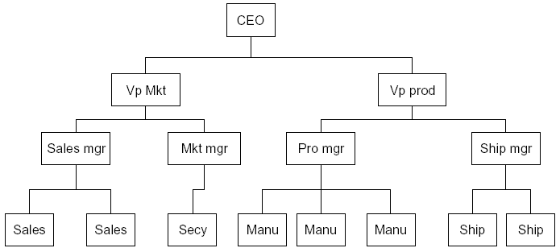
Each of these company members may receive a salary, and we could at any time ask for the cost of any employee to the company. We define the cost as the salary of that employee and those of all his subordinates.
- The cost of an individual employee is simply his salary (and benefits).
- The cost of an employee who heads a department is his salary plus those of all his subordinates.
可以完成的功能要求：可以实现访问公司每个雇员的薪水(salary)及对公司的贡献价值(cost)。

Employee employee = new Employee();
employee.getSalary(){
return salary;
}

employee.getCost() {

For (i=0, i< getNumberOfEmployee(),i++) {

Employee employee = getEmployee( i)

total += employee.getSalary();
}

}

